Assignment -1.5
AI Assisted Coding
Name:M. Sprusheeth Rao
Roll Number: 2303A51194
Batch - 04
09-01-2026
Task 0: Environment Setup:-
Task 0
● Install and configure GitHub Copilot in VS Code. Take screenshots of
each step.
Expected Output
● Install and configure GitHub Copilot in VS Code. Take screenshots of
each step.
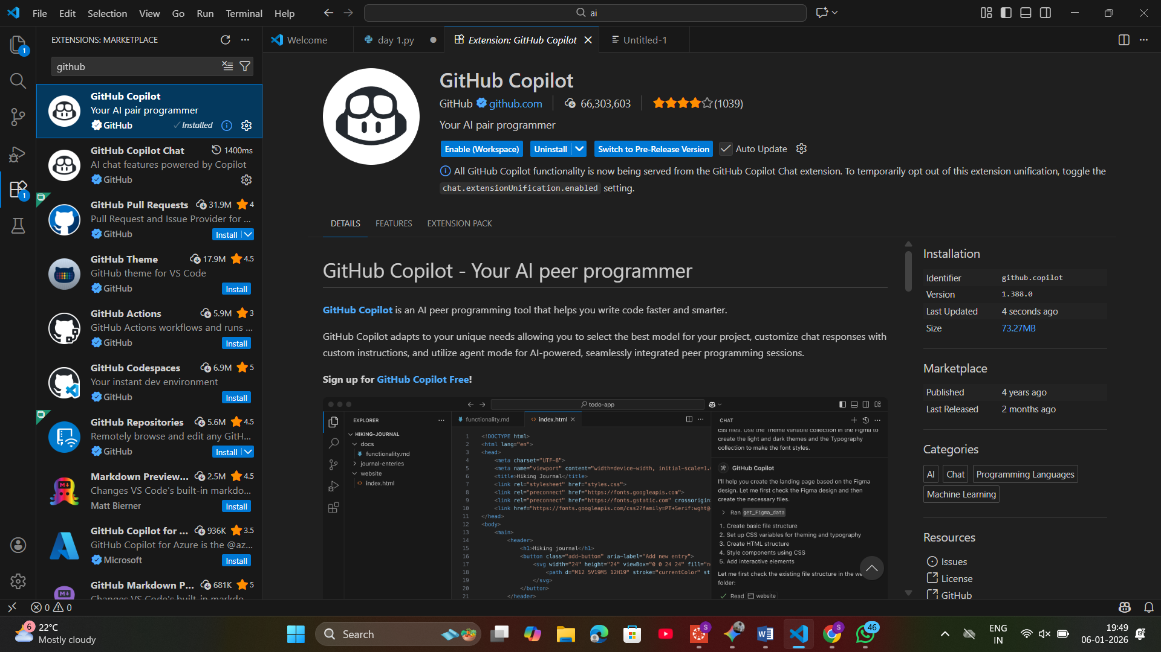
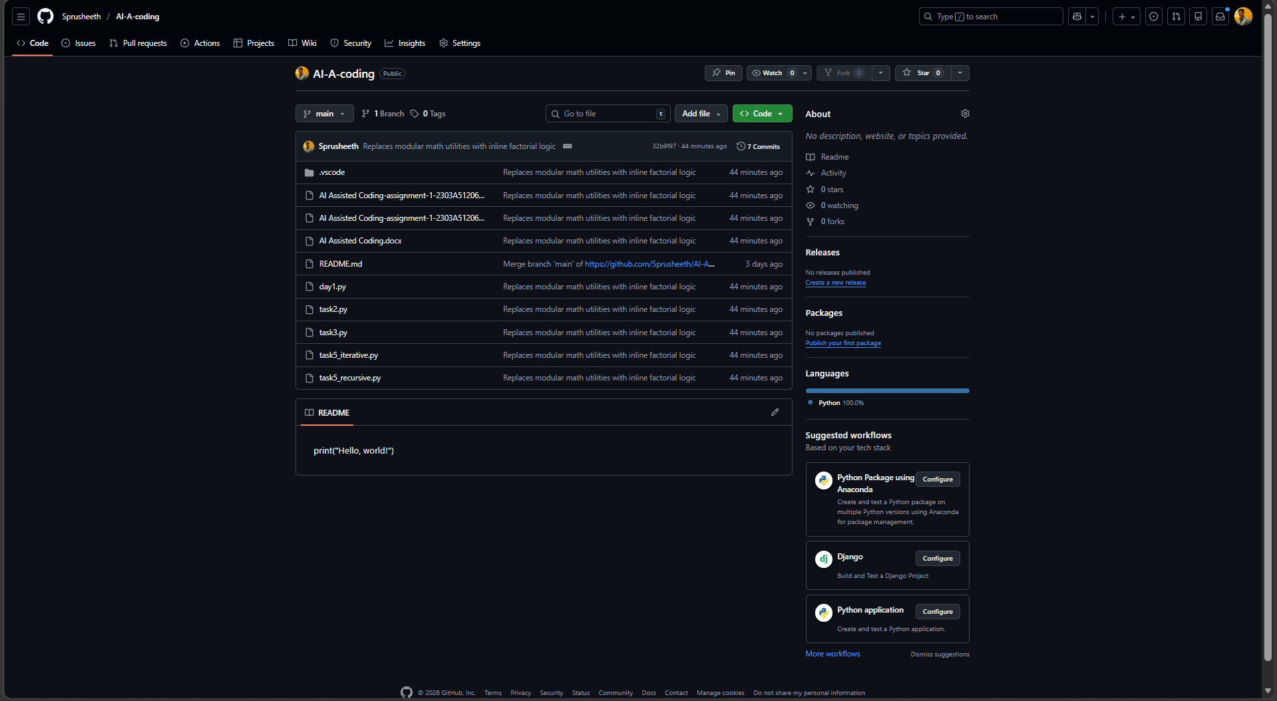
Task 1: Non-Modular Logic (Factorial):-
: AI-Generated Logic Without Modularization (String Reversal Without
Functions)
❖ Scenario
You are developing a basic text-processing utility for a messaging
application.
❖ Task Description
Use GitHub Copilot to generate a Python program that:
➢ Reverses a given string
➢ Accepts user input
➢ Implements the logic directly in the main code
➢ Does not use any user-defined functions
❖ Expected Output
➢ Correct reversed string
➢ Screenshots showing Copilot-generated code suggestions
➢ Sample inputs and outputs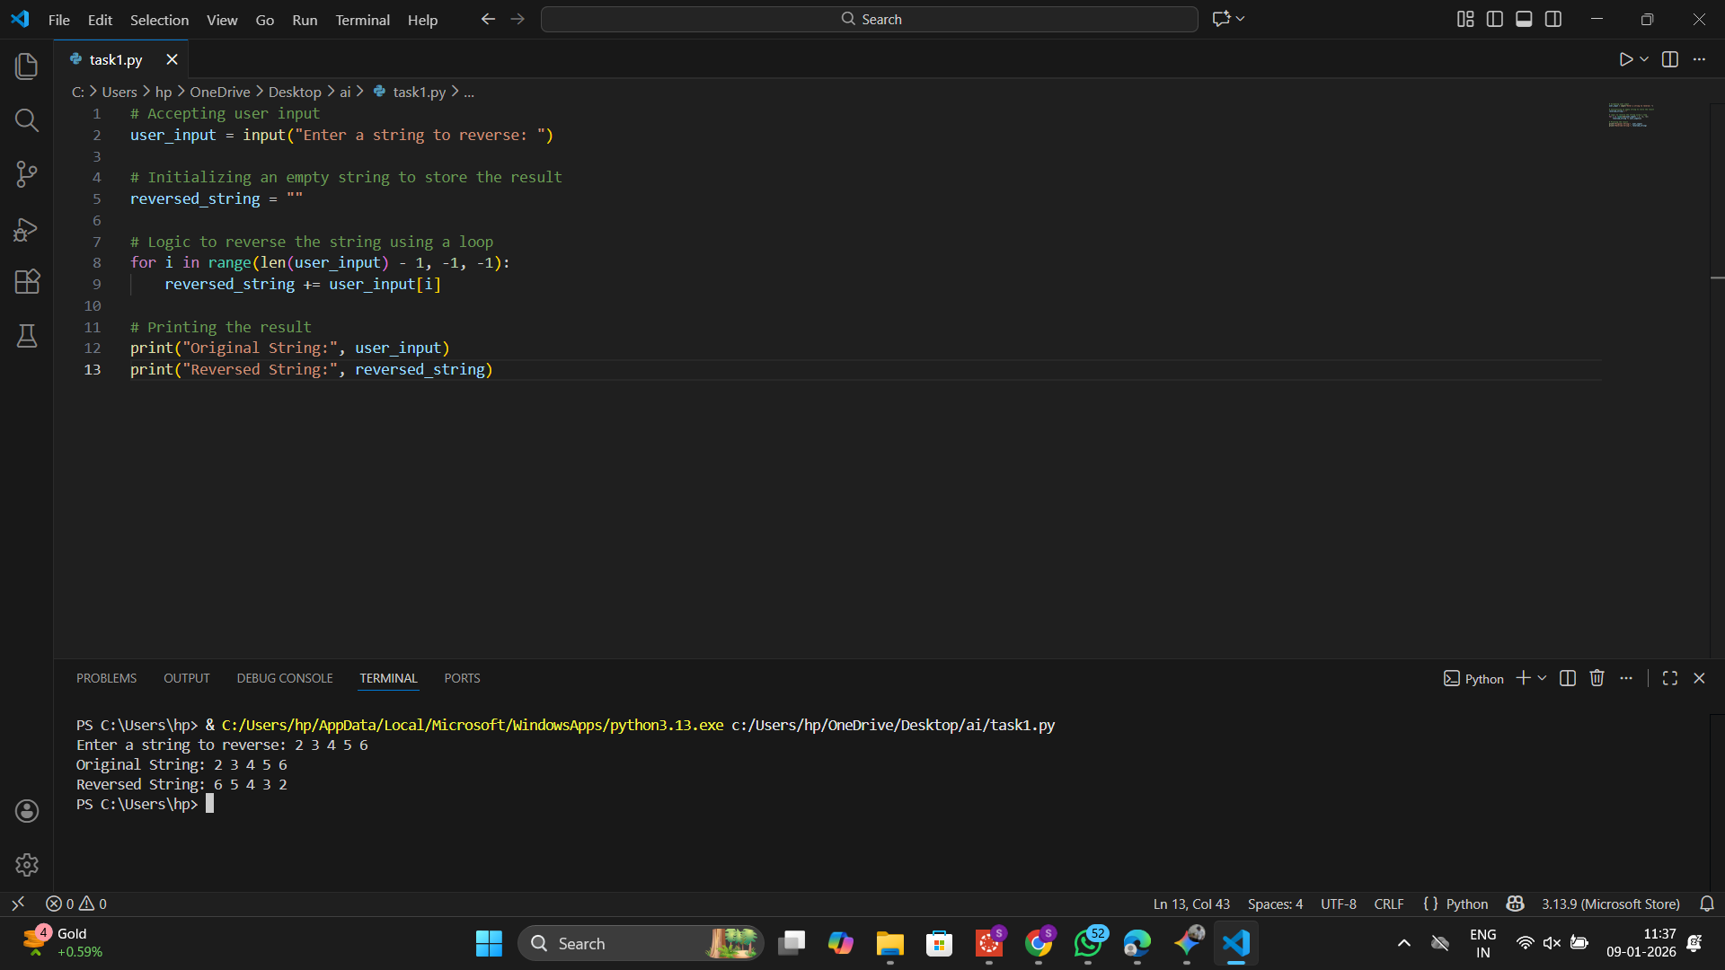
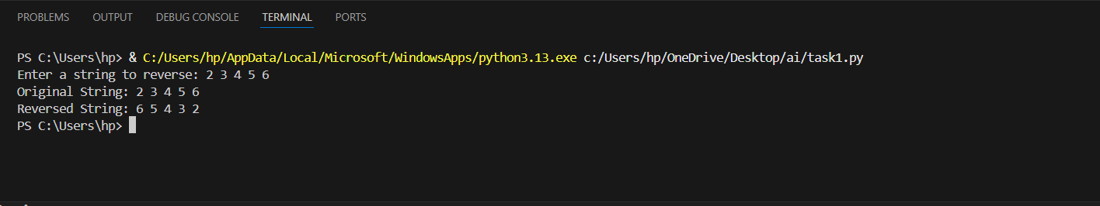
Task 2: AI Code Optimization:-
Efficiency & Logic Optimization (Readability Improvement)
❖ Scenario
The code will be reviewed by other developers.
❖ Task Description
Examine the Copilot-generated code from Task 1 and improve it by:
➢ Removing unnecessary variables
➢ Simplifying loop or indexing logic
➢ Improving readability
➢ Use Copilot prompts like:
▪ “Simplify this string reversal code”
▪ “Improve readability and efficiency”
Hint:
Prompt Copilot with phrases like
“optimize this code”, “simplify logic”, or “make it more readable”
❖ Expected Output
➢ Original and optimized code versions
➢ Explanation of how the improvements reduce time complexity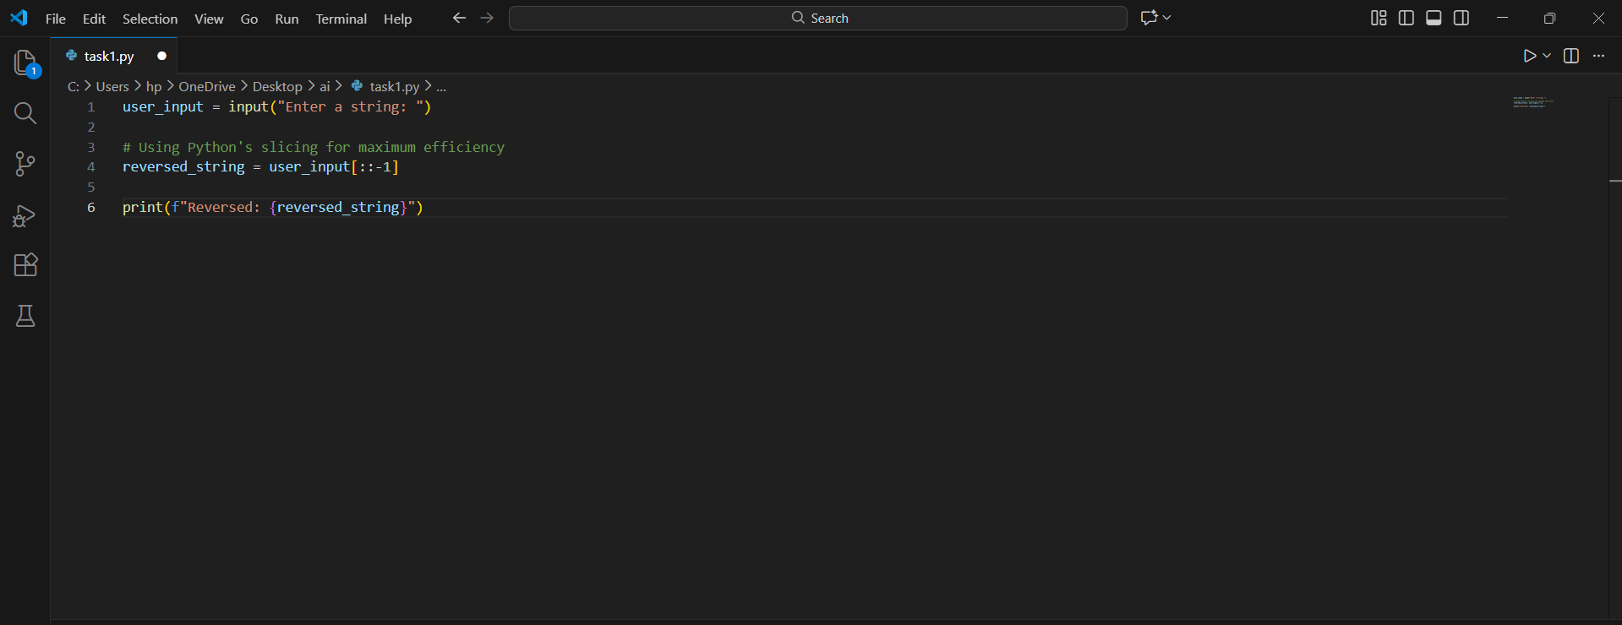
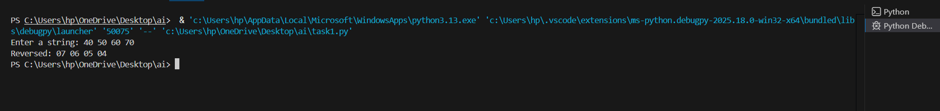
Task 3: Modular Design Using AI Assistance (String Reversal Using Functions)
❖ Scenario
The string reversal logic is needed in multiple parts of an application.
❖ Task Description
Use GitHub Copilot to generate a function-based Python program that:
➢ Uses a user-defined function to reverse a string
➢ Returns the reversed string
➢ Includes meaningful comments (AI-assisted)
❖ Expected Output
➢ Correct function-based implementation
➢ Screenshots documenting Copilot’s function generation
➢ Sample test cases and outputs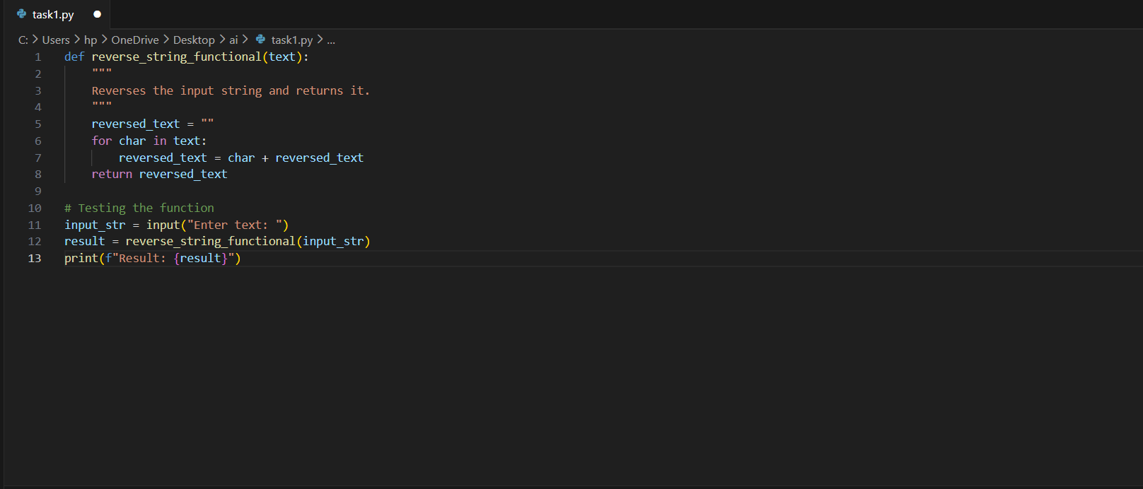
Task 4: Comparative Analysis – Procedural vs Modular Approach (With vs
Without Functions)
❖ Scenario
You are asked to justify design choices during a code review.
❖ Task Description
Compare the Copilot-generated programs:
➢ Without functions (Task 1)
➢ With functions (Task 3)
Analyze them based on:
➢ Code clarity
➢ Reusability
➢ Debugging ease
➢ Suitability for large-scale applications
❖ Expected Output
Comparison table or short analytical report
Feature | Procedural (Without Functions) | Modular (With Functions)
Code Clarity | Easy for tiny scripts; messy for large ones. | Very high; logic is isolated and named.
Reusability | Must copy-paste code to use it again. | Can be called anywhere in the app.
Debugging | Harder to isolate where an error occurs. | Easy to unit test the specific function.
Scalability | Not suitable for large applications. | Essential for professional development.

Task 5: AI-Generated Iterative vs Recursive Fibonacci Approaches (Different
Algorithmic Approaches to String Reversal)
❖ Scenario
Your mentor wants to evaluate how AI handles alternative logic paths.
❖ Task Description
Prompt GitHub Copilot to generate:
➢ A loop-based string reversal approach
➢ A built-in / slicing-based string reversal approach
❖ Expected Output
➢ Two correct implementations
➢ Comparison discussing:
▪ Execution flow
▪ Time complexity
▪ Performance for large inputs
▪ When each approach is appropriate.
